A collector of antique grandfather clocks sold at auction believes that the price received for the clocks depends on both the age of the clocks and the number of bidders at the auction. A sample of 32 auction prices of grandfather clocks, along with their age and the number of bidders, is given in GFCLOCKS

a. Use scattergrams to plot the sample data. Interpret the plots.

b. Use the method of least squares to estimate the unknown parameters $β_{0}$, $β_{1}$, and $β_{2}$ of the model.

c. Find the value of SSE that is minimized by the least squares method.

d. Find the MSE (mean square error) and Root MSE. What is the root MSE?

e. Is the regression model appropriate here? Write down the null and alternative hypothesis and make your conclusion based on the appropriate test.

f. Test the hypothesis that the mean auction price of a clock increases as the number of bidders increases when age is held constant.

g. Form a 95% confidence interval for $β_{1}$ and interpret the result.

h. Estimate the average auction price for all 150-year-old clocks sold at auctions with 10 bidders using a 95% confidence interval. Interpret the result.

i. Predict the auction price for a single 150-year-old clock sold at an auction with 10 bidders using a 95% prediction interval. Interpret the result.

j. Suppose you want to predict the auction price for one clock that is 50 years old and has two bidders. How should you proceed?

k. Suppose the collector of grandfather clocks, having observed many auctions, believes that the rate of increase of the auction price with age will be driven upward by a large number of bidders. Thus, instead of a relationship like that shown in Figure a, in which the rate of increase in price with age is the same for any number of bidders, the collector believes the relationship is like that shown in Figure b. Note that as the number of bidders increases from 5 to 15, the slope of the price versus age line increases.

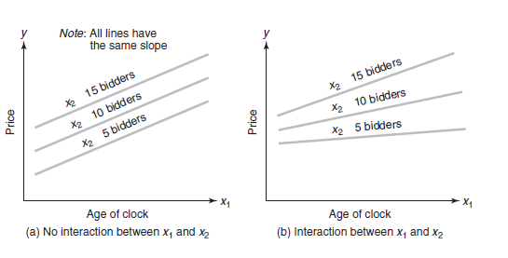

l. Test the overall utility of the model using the global F-test at $α$ = .05.

m. Test the hypothesis (at $α$ = .05) that the price–age slope increases as the number of bidders increases—that is, that age and number of bidders, x2, interact positively.

n. Estimate the change in auction price of a 150-year-old grandfather clock, y, for each additional bidder.

